**Build HTML Code**

In this HTML page, we will create the front-end part of the web page. On this page, we will accept input from the user and Predict the values.

For more information regarding HTML, click on the [link](https://www.w3schools.com/html/).

In our project we have HTML files, they are

**1.index.html - paste the image**

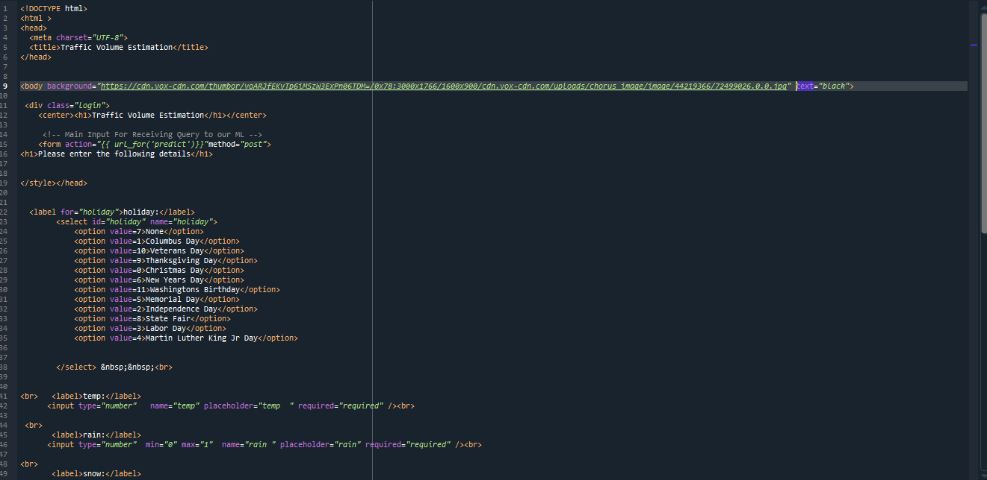

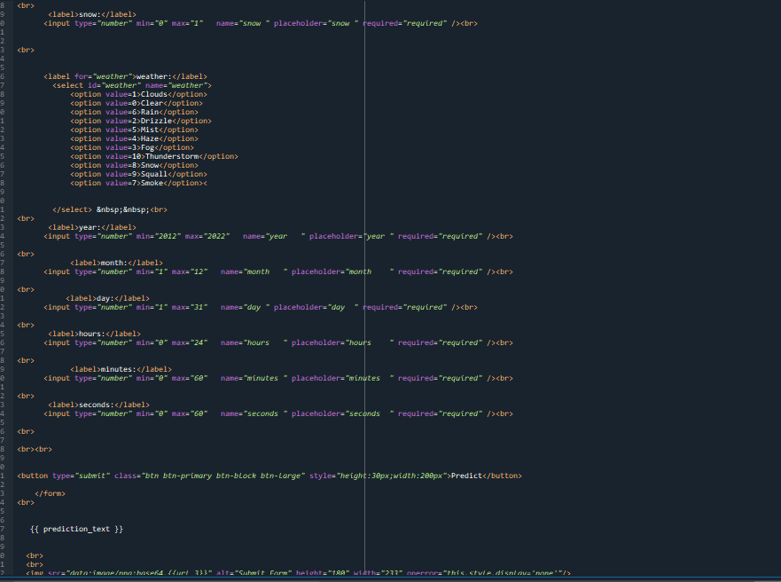

**2. The HTML page looks like this-**

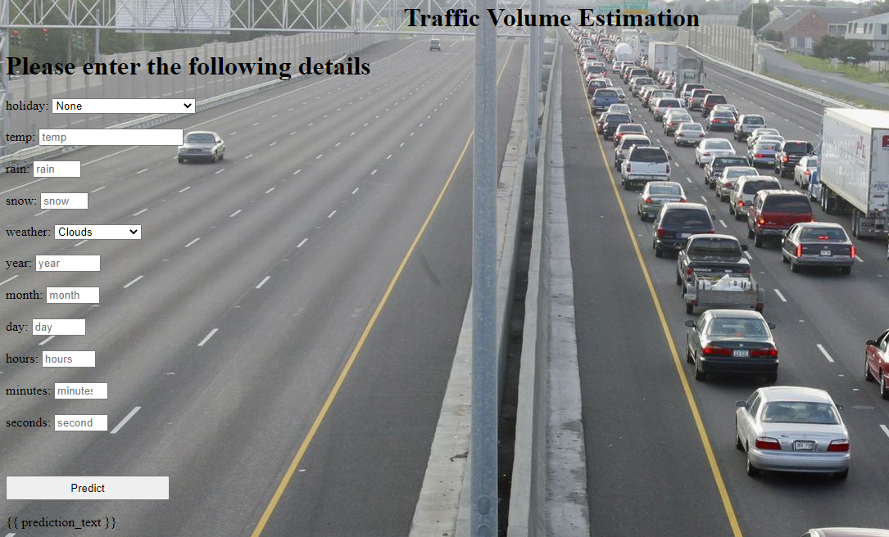

**3. It will display all the input parameters and the prediction text will display the output value of the data given by the user**..

